1. **Create a schema based on the given dataset**

hive> create table agent_loging_report

> (

> sl_no int,

> agent string,

> date date,

> login_time string,

> logout_time string,

> duration string

> )

> row format delimited

> fields terminated by ','

> tblproperties("skip.header.line.count" = "1");

hive> create table agent_performance

> (

> sl_no int,

> date date,

> name string,

> total_chats int,

> avg_response_time string,

> avg_resolution_time string,

> avg_rating float,

> total_feedback int

> )

> row format delimited

> fields terminated by ','

> tblproperties("skip.header.line.count" = "1");

1. **Dump the data inside the hdfs in the given schema location**

hive> load data local inpath '/home/cloudera/data/AgentLogingReport.csv' into table agent_loging_report;

hive> load data local inpath '/home/cloudera/data/AgentPerformance.csv' into table agent_performance;

1. **List of all agents' names**

select agent from agent_loging_report;

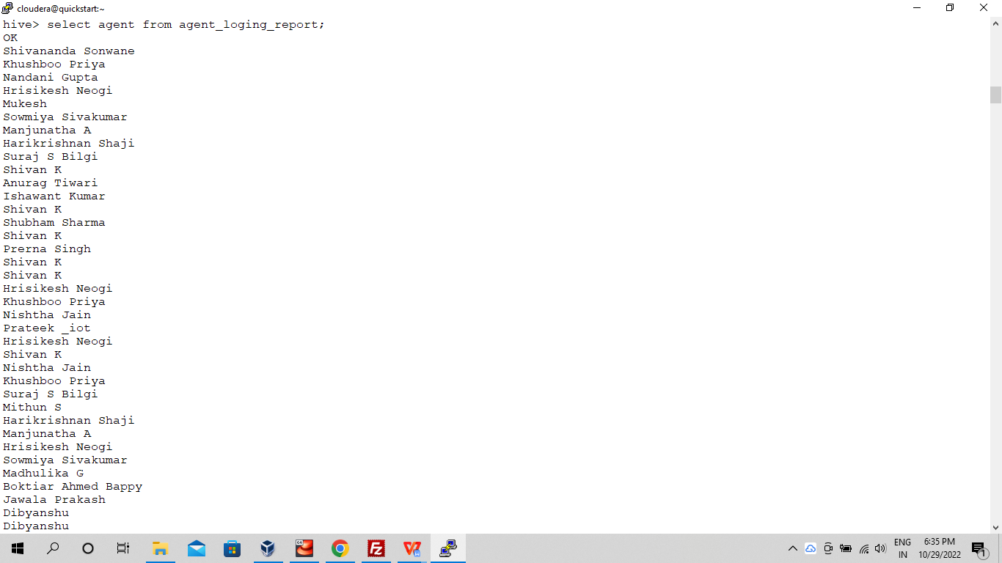

1. **Find out agent average rating**

select name, avg(avg_rating) from agent_performance group by name limit 10;

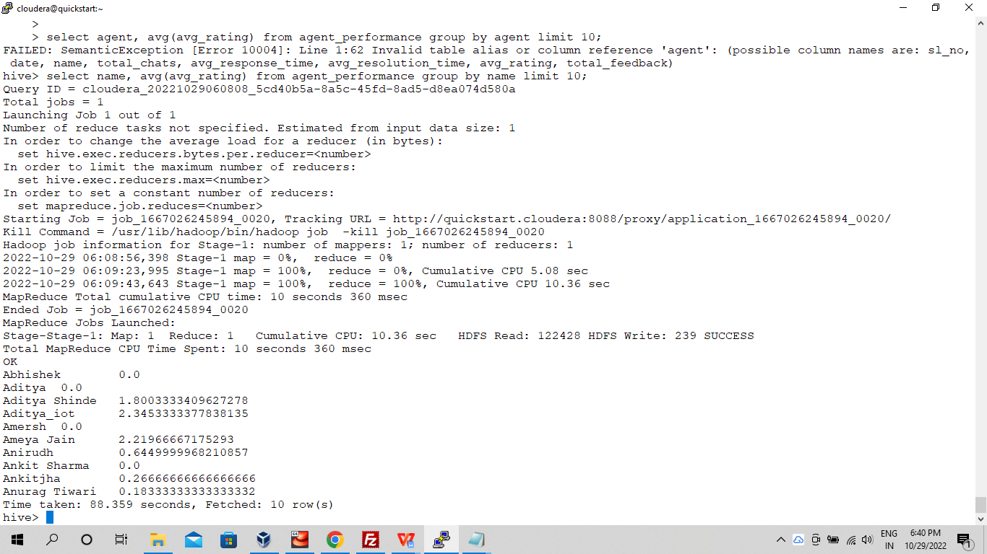

1. **Total working days for each agents**

select agent, count(date) as total_working_days from agent_loging_report group by agent limit 5;

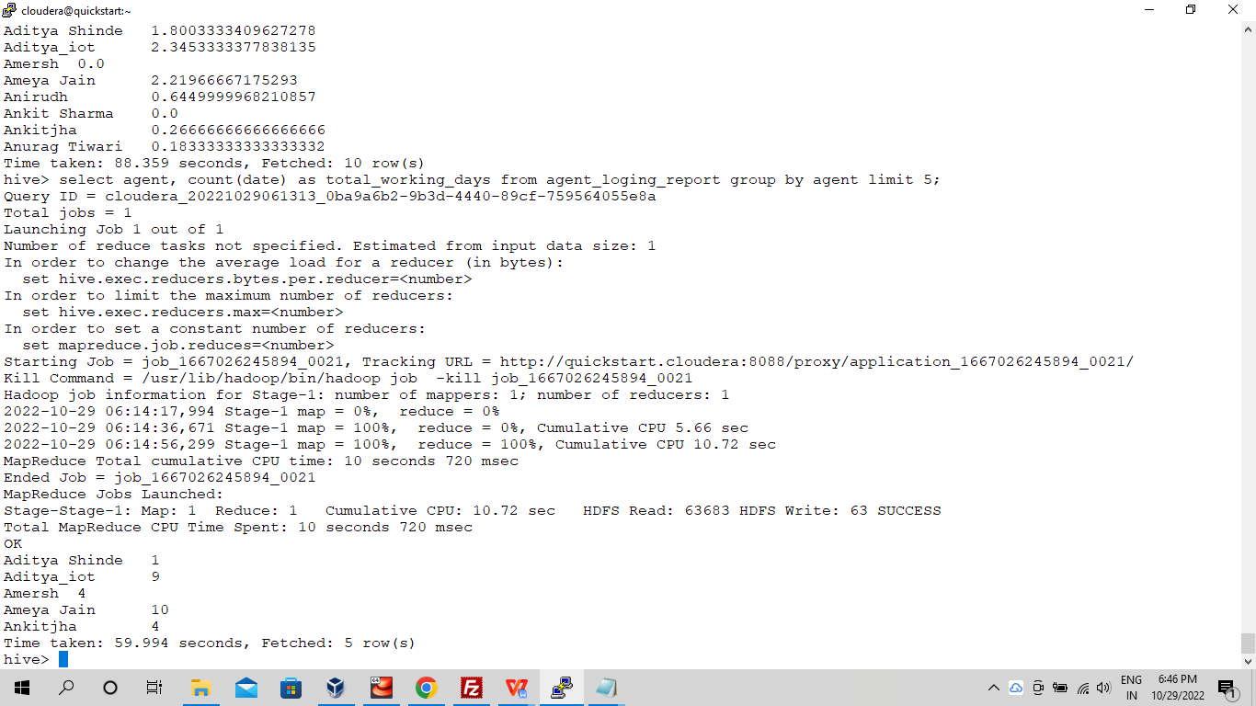

1. **Total query that each agent have taken**

select name, sum(total_chats) as queries from agent_performance group by name limit 5;

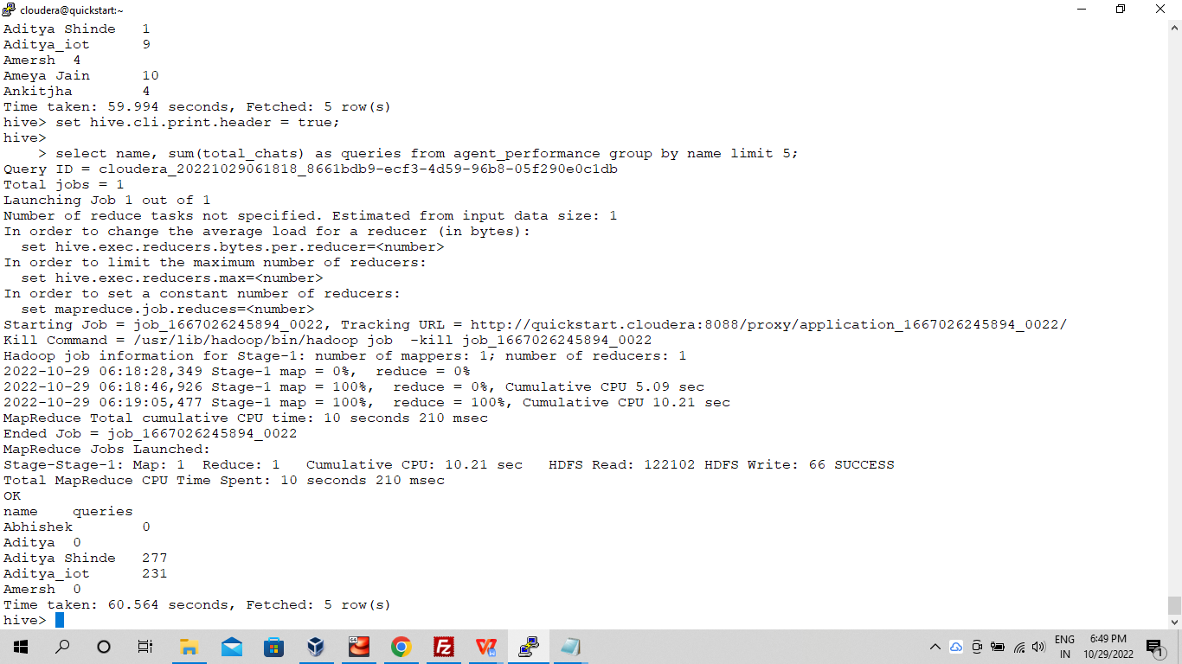

1. **Total Feedback that each agent have received**

select name, sum(total_feedback) as feedback_received from agent_performance group by name limit 5;

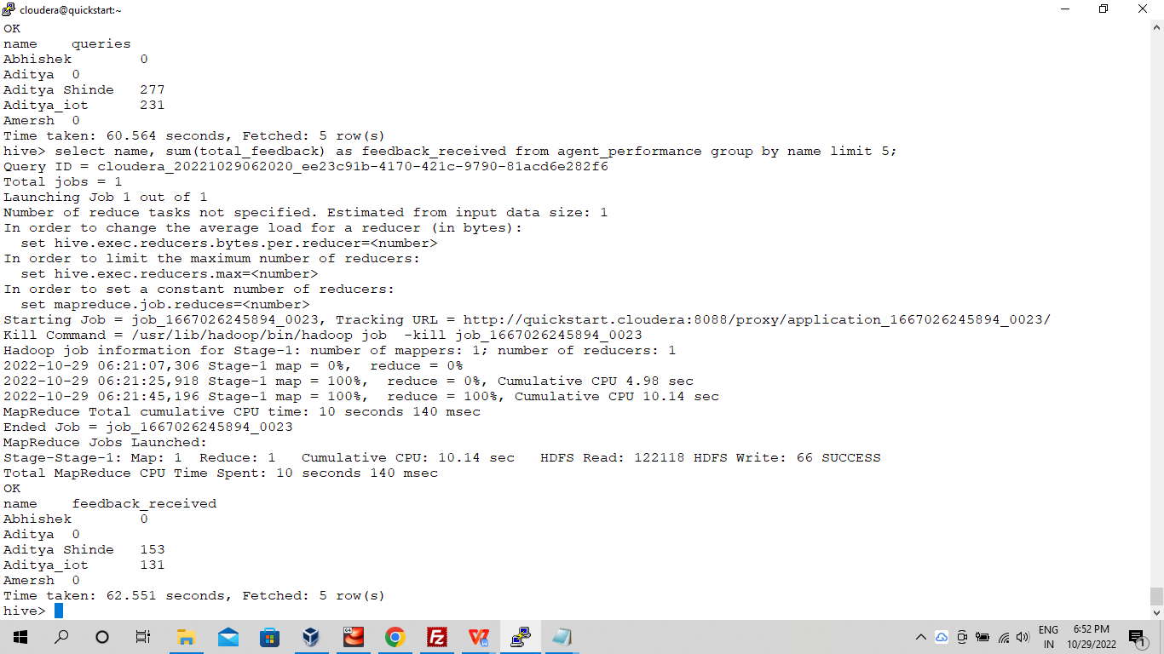

1. **Agent name who have average rating between 3.5 to 4**

select name from agent_performance where avg_rating between '3.5' and '4';

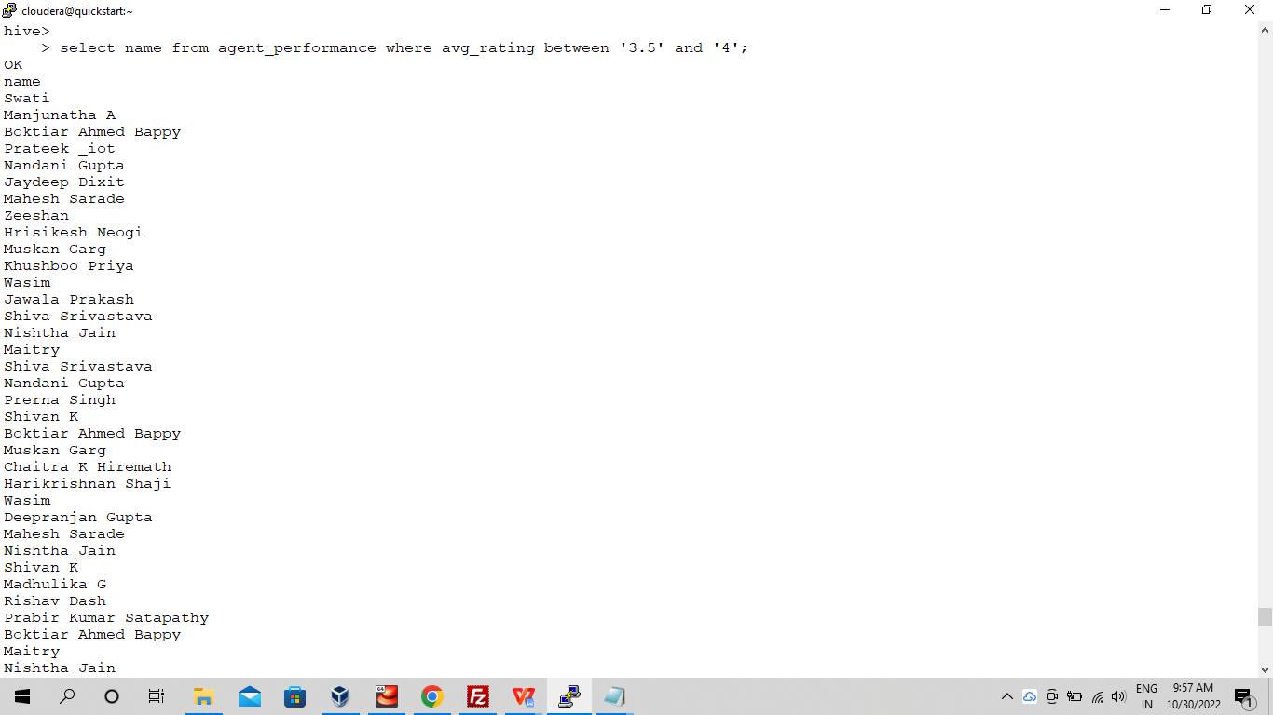

1. **Agent name who have rating less than 3.5**

select name from agent_performance where avg_rating < 3.5 limit 5;

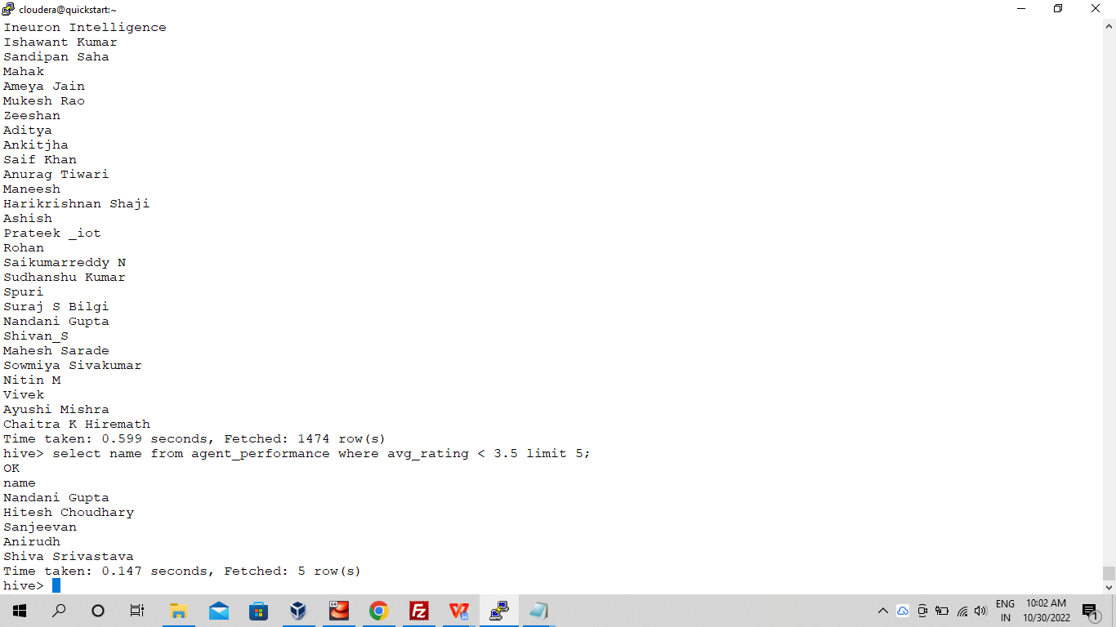

1. Agent name who have rating more than 4.5

select name from agent_performance where avg_rating > 4.5 limit 5;

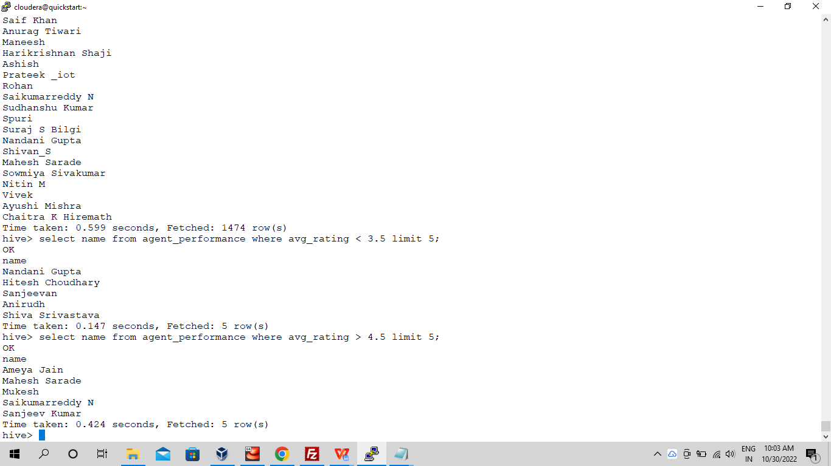

1. **How many feedback agents have received more than 4.5 average**

select name, avg(total_feedback) as feedback from agent_performance group by name having avg(total_feedback) > 4.5;

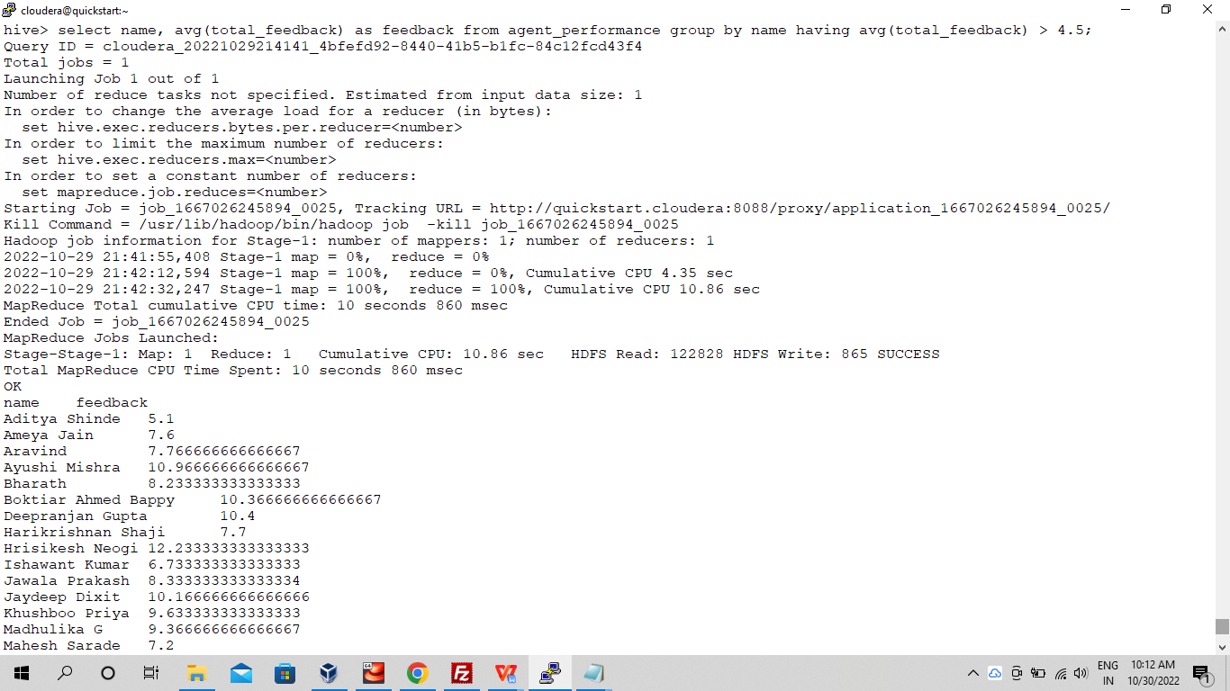

1. **average weekly response time for each agent**
2. **average weekly resolution time for each agents**
3. **Find the number of chat on which they have received a feedback**

select name, sum(total_chats) as total_chats, total_feedback from agent_performance where total_feedback > 0 group by name, total_feedback limit 5;

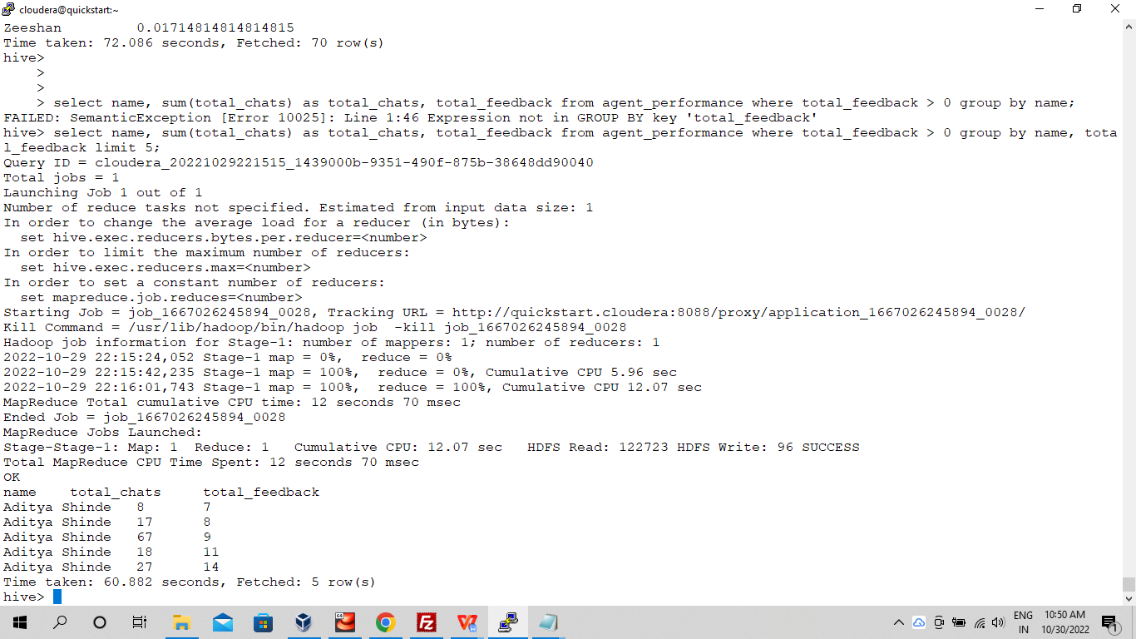

1. **Total contribution hour for each and every agents weekly basis**
2. **Perform inner join, left join and right join based on the agent column and after joining the table export that data into your local system**

hive -e 'select l.agent, a.total_chats, a.avg_response_time from mini_project_1.agent_loging_report l inner join mini_project_1.agent_performance a on l.agent = a.name limit 5;' > /home/cloudera/data/inner_join.csv;

hive -e 'select l.agent, a.total_chats, a.avg_response_time from mini_project_1.agent_loging_report l left join mini_project_1.agent_performance a on l.agent = a.name limit 5;' > /home/cloudera/data/left_join.csv;

hive -e 'select l.agent, a.total_chats, a.avg_response_time from mini_project_1.agent_loging_report l right join mini_project_1.agent_performance a on l.agent = a.name limit 5;' > /home/cloudera/data/right_join.csv;

1. **Perform partitioning on top of the agent column and then on top of that perform bucketing for each partitioning**

hive> create table agent_details

> (

> sl_no int,

> total_chats int,avg_response_time string

> )

> partitioned by (name string)

> clustered by (sl_no)

> sorted by (sl_no)

> into 2 buckets;

hive> insert overwrite table agent_details partition(name) select sl_no, total_chats, avg_response_time, name from agent_performance;

